Please complete and send the order form by email : cs@theheer.com
Or support@theheer.com
Product Code | Short note about the product such as customisations etc. | *Unit Price | Qty | *Total

 | *Sub Total:
**For shipping fees please visit at:  http://www.theheer.com/charges.html | *Shipping**
Insurance (Optional)
(2% of the total cost)
*Note: All prices on our website are in United States  Dollars.  Payment transfer information is on page no. 4. | *Grand Total

First Name: |  | Last Name:
Address:
City: |  | State/County:
Zip/Postal |  | Country:
Email: |  | Phone(Landline):  Cell Phone:

Signature:

Top:
 | Bottom:
  Figure size | Inches | or | CM
1. Neck Circumference: | 13. Trouser Waist Circumference:
2. Cross Shoulder: | 14. Hips Circumference:
3. Bust Circumference: | 15: Crotch:
4. Sleeve Length (Optional): | 16. Thigh Circumference:
5. Biceps (Optional): | 17. Knee Circumference (Optional):
6. Armhole: | 18. Calf Circumference (Optional):
7. Head Circumference (Optional): | 19. Trouser Length:
8. Shirt Length: | 20. Trouser Inseam (Optional):
9. Neck to Bust Point (Optional): | 21. Trouser Waist to Knee (Optional):
10. Bust Point to Bust Point: | 22. Trouser Cuff (Optional):
11. Shirt Waist Circumference: | 23. Your Height:
12. Central Back Neck (Optional): | 24. Your Weight (Optional):
If you have more than one measurement please make as many copies as you need by clicking on File > Save As from the pop-up menu.

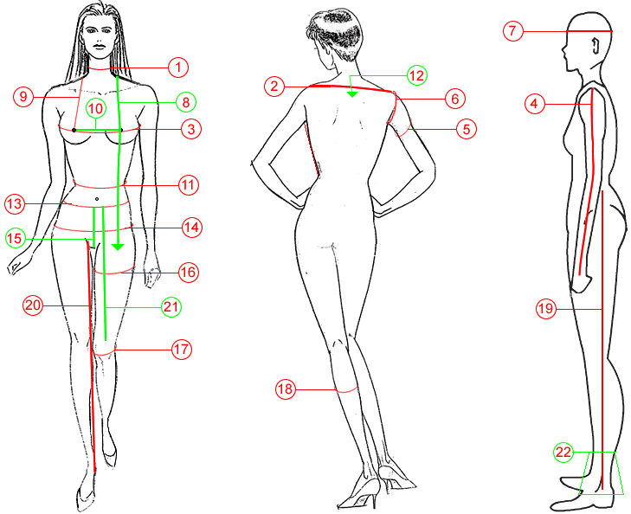
Write here Additional Notes, if any:

Measurement Details
You may leave some measurements that are only needed for specific outfits. Make sure you measure carefully and double check with it. It is a good idea to have someone else measures you.

Please keep in mind that you should be wearing normal clothes or undergarments. Jeans and heavy blouses are not recommended while being measured. Lay the tape measure flat against the skin; don't pull it too tight, nor let it droop.

1. Neck Circumference
Measure round your neck in inches. Let the tape measure rest on your clavicle.
2. Cross Shoulder
The horizontal width measurement from shoulder point to shoulder point. Take measurement at back shoulder.
3. Bust/Chest Circumference
Place tape measure round your chest at the fullest expanse of the bust.
4. Sleeve Length
Measure from the top of your shoulder to your wrist.
5. Bicep
Pace tape measure round your widest muscle of arm.
6. Armhole
Lift the arm a little and bend the elbow slightly - measure around the armhole loosely so that it will not bind when the arm is lifted up and down.
7. Head Circumference
Place tape measure round the head. This measurement is required for high necks or stand collars.
8. Shirt Length
Measure from shoulder to over bust and down to as long as you want. Usually down to bellybutton or slightly above the knee cap recommended for Shalwar Kameez and Trouser Suits.
9. Neck to Bust Point
Place tape measure to the point where neck is starting to the bust point.
10. Bust Point to Bust Point
Place tape measure from bust point to bust point.
11. Shirt Waist
Place tape measure round the natural waistline.
12. Central back neck
Place tape measures to centre of the back neck to the point you require the depth.
13. Trouser Waist Circumference
Place tape measure round the trouser waistline.
14. Hip Circumference
The circumference along the horizontal line at the widest point of the hip across the fullest part of the buttocks and over the end of the thigh bone.
15. Crotch
Trouser waist to joined of the leg. You can also take crotch depth by sitting down on a flat hard chair. Take the measurement on the side from the waist to the chair.
16. Thigh Circumference
Take thigh circumference round the widest part of the leg. High up on the leg, just below the crotch.
17. Knee Circumference
Measure around the knee little loosely.
18. Calf Circumference
Measure the girth around the largest part of the calf.
19. Trouser Length
Measure as outer length of trouser including waistband. This is the length from top of where you wear your trouser at the waist down till where the trouser hem skims your feet.
20. Trouser Inseam
Take inseam measurement from the crotch, where two legs join, to bottom of the leg.
21. Trouser Waist to Knee
Place tape measure to the trouser waist until knee cap. This measurement is usually required for ghararas, fishtail and mermaid cuts.
22. Trouser Cuffs
The round area on the bottoms of trouser legs.

Payment Methods
Please use the following services to transfer your money for online order:
- Cash/Credit/Debit card/Paypal at our Store/Online by 2Checkout.com
- Direct Debit / Bank Wire Transfer (USD, GBP, EURO, PAK)
- Pay by Western Union
- Pay by Moneygram
- Pay Paypal
- Pay by Cheque (use USD bank wire info only)
- Deposit money into our account (check bank wire info)
- Pay by Money Order
If you have any queries about payment options please contact customer service by clicking here.

::::: A. Online :::::
We Accept Credit Cards, PayPal, and Debit Cards through 2Chechout.com. Online payment accepted by only these 8 following cards:
- Visa card Card
- Discover
- American Express
- Diners
- JCB
- PIN debit cards with the Visa or MasterCard logo
- Debit cards with the Visa or MasterCard logo
- PayPal
Some of these options are only available in select currencies.
::::: B. Bank Wire Transfer Information:::::
USD Account:
Payee / Beneficiary / Account Title: The Heer
Beneficiary Bank Account Number: 1307-206497648
Payee / Beneficiary Address: 52-55 Mezzanine Floor, Gulberg Arcade, Main
Market Gulberg II, Lahore Pakistan 54660
Bank Name: United Bank LTD.
Bank IBAN Number: PK84UNIL0000000206497648
Swift Code or Sort Code: UNILPKKA
Bank Branch Address: Amin chamber, 1-E, Amin Chamber, Main Market Gulbe,
Lahore Pakistan
Branch code: 1307
Branch Name: Amin Chamber
Pak Rupee Account:
Payee / Beneficiary / Account Title: The Heer
Beneficiary Bank Account Number: 1307-206316848
Payee / Beneficiary Address: 52-55 Mezzanine Floor, Gulberg Arcade, Main
Market Gulberg II, Lahore Pakistan 54660
Bank Name: United Bank LTD.
Bank IBAN Number: PK62UNIL0000000206316848
Swift Code or Sort Code: UNILPKKA
Bank Branch Address: Amin chamber, 1-E, Amin Chamber, Main Market Gulbe,
Lahore Pakistan
Branch code: 1307
Branch Name: Amin Chamber
Personal Pak Rupee Account for western Union Online Transfer Only:
Payee / Beneficiary / Account Title / 1st Name: Muhammad Umar
2nd Name/Sur Name: Ejaz Chaudhry
Beneficiary Bank Account Number: 130710081542
Payee / Beneficiary Address: 52-55 Mezzanine Floor, Gulberg Arcade, Main
Market Gulberg II, Lahore Pakistan
Bank Name: United Bank LTD
Bank IBAN Number: PK08UNIL0000130710081542
Swift Code or Sort Code: UNILPKKA
Bank Branch Address: Amin chamber, 1-E, Amin Chamber, Main Market Gulbe,
Lahore Pakistan
Branch code: 1307
Branch Name: Amin Chamber
::::: C. Western Union Money Transfer information:::::
Western Union recipient info as follows:
You can send payment easily by visiting nearest Western Union office and simply provide them our Western Union recipient info that given below.
Receiver's First Name: Mohammad Omar
Last Name: Ejaz Chaudhry
Receiver’s Address: 52-55 Mezzanine Floor, Gulberg Arcade, Main Market Gulberg II, Lahore Pakistan
City: Lahore
Post Code: 54600
Country: Pakistan
Telephone: 00923454928442
::::: D. MoneyGram International information :::::
Money Gram recipient info as follows:
You can send payment easily by visiting nearest MoneyGram office andsimply provide them our Moneygram recipient info that given below:
Receiver's First Name: Mohammad Omar
Last Name: Ejaz Chaudhry
Receiver’s Address: 52-55 Mezzanine Floor, Gulberg Arcade, Main Market Gulberg II, Lahore Pakistan
City: Lahore
Post Code: 54600
Country: Pakistan
Telephone: 00923454928442
If you want to place your order using a credit card or online, There are
several options for sending money through our online payment method 2Checkot or at our store.
Our order form contains payment transfer information on page no. 4. or use following payment information
::::: 1. Bank Wire Transfer Information :::::
Personal Pak Rupee Account for western Union Online Transfer Only:
Payee / Beneficiary / Account Title / 1st Name: Muhammad Umar
2nd Name/Sur Name: Ejaz Chaudhry
Beneficiary Bank Account Number: 130710081542
Payee / Beneficiary Address: 52-55 Mezzanine Floor, Gulberg Arcade, Main
Market Gulberg II, Lahore Pakistan
Bank Name: United Bank LTD
Bank IBAN Number: PK08UNIL0000130710081542
Swift Code or Sort Code: UNILPKKA
Bank Branch Address: Amin chamber, 1-E, Amin Chamber, Main Market Gulbe,
Lahore Pakistan
Branch code: 1307
Branch Name: Amin Chamber
Receiver's First Name: Mohammad Omar
Last Name: Ejaz Chaudhry
Receiver’s Address: 52-55 Mezzanine Floor, Gulberg Arcade, Main Market Gulberg II, Lahore Pakistan
City: Lahore
Post Code: 54600
Country: Pakistan
Telephone: 0923454928442
You can send order Payment By online, By Paypal, Through your bank online, or by nearest money transfer stores. If you have any questions regarding these services we can guide you.
Once funds are transferred please provide us payment informatio with Control Number (Reference Code) and sender details so recipient can collect the payment. You can call or email your Money Gram Control Number. See Phone, email info below.
For Money Gram/Western Union payment please visits your nearest Money Gram/ Western Union agent location (Find nearest agent at http://www. moneygram.com www.WesternUnion.com) or make payment online on money gram/ Western Union website.
Money Gram/ Western Union accept credit/debit card payment online at http://www.moneygram.com www.WesternUnion.com for customers from Australia, Austria, Canada, France, Germany, Ireland, Italy, Netherlands, New Zealand, Norway, Spain
,Sweden, United Kingdom and United States.
Please send us this form with Money Gram/Western Union Control Number at one of the following email address:
cs@theheer.com
support@theheer.com
Address: The Heer Boutique 52-55 MZ, Gulberg Arcade,
Main Market Gulberg II, Lahore Pakistan 54660
Website: http://www.theheer.com/
Phone: +92427012439 +923454928442 +923454027608
Email: cs@theheer.com support@theheer.com

